1.What are the two values of the Boolean data type? How do you write them?

True and false

2. What are the three different types of Boolean operators?

Greater than a>

Lesser than <

== equal to

!= not equal to

3. Make a list of each Boolean operator's truth tables (i.e. every possible combination of Boolean values for the operator and what it evaluate ).

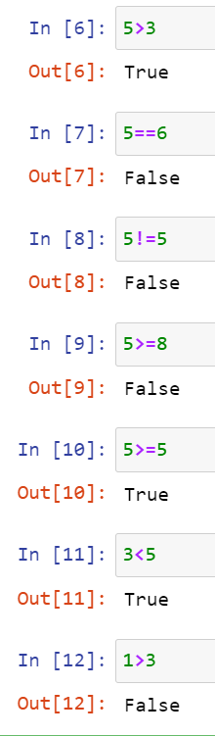

4. What are the values of the following expressions?

(5 > 4)(true) and (3 == 5)(false)

not (5 > 4)(false)

(5 > 4) or (3 == 5) (true)

not ((5 > 4) or (3 == 5))(false)

(True and True) and (True == False)(true)

(not False) or (not True)(true)

5. What are the six comparison operators?



6. How do you tell the difference between the equal to and assignment operators?Describe a condition and when you would use one.

using if condition we able to identify the number

x=int(input(“))

if x>5:

print(“its not greater than 5”)

7. Identify the three blocks in this code:

spam = 0

if spam == 10:

print('eggs')

if spam > 5:

print('bacon')

else:

print('ham')

print('spam')

print('spam')

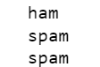

This is a output I got from there

8. Write code that prints Hello if 1 is stored in spam, prints Howdy if 2 is stored in spam, and prints Greetings! if anything else is stored in spam.

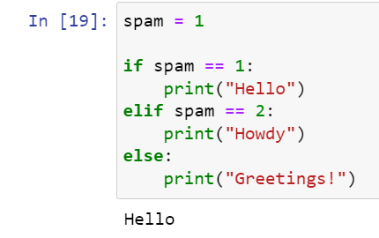

9.If your programme is stuck in an endless loop, what keys you’ll press?

10. How can you tell the difference between break and continue?

Break is used end the loop and print the output

continue will stop at the specific part and continue the loop

11. In a for loop, what is the difference between range(10), range(0, 10), and range(0, 10, 1)?

Range(10) it will just give you the range

Range(0,10)

It do not give the value

Range(0,10,1)

It will give you the sequence of numbers between 0 to 10

12. Write a short program that prints the numbers 1 to 10 using a for loop. Then write an equivalent program that prints the numbers 1 to 10 using a while loop.

For in range (1,11)

Print(i)

13. If you had a function named bacon() inside a module named spam, how would you call it after importing spam?

There is an in this question